**Write a code in cpp swapping two value use Reference**

#include <iostream>

using namespace std;

void passbyVal(int a, int b) {

int temp = a;

a = b;

b = temp;

}

void passbyRe(int &a, int &b) {

int temp = a;

a = b;

b = temp;

}

int main() {

int a = 20, b = 30;

cout << "Original values: a = " << a << ", b = " << b << endl;

passbyVal(a, b);

cout << "After passbyVal: a = " << a << ", b = " << b << endl;

passbyRe(a, b);

cout << "After passbyRe: a = " << a << ", b = " << b << endl;

return 0;

}

**Output:**

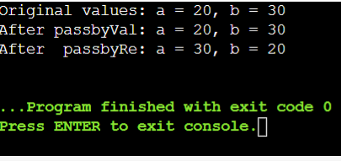

**Ambiguity:**

#include<iostream>

using namespace std;

void test(int a){

cout<<"x is"<<a<<endl;

}

void test(int a,int b=6)

{

cout<<"x is"<<a<<endl<<"y is"<<endl;

}

int main(){

int x=5,y=6;

test(x);

test(x,y);

return 0;

}

**Output:**

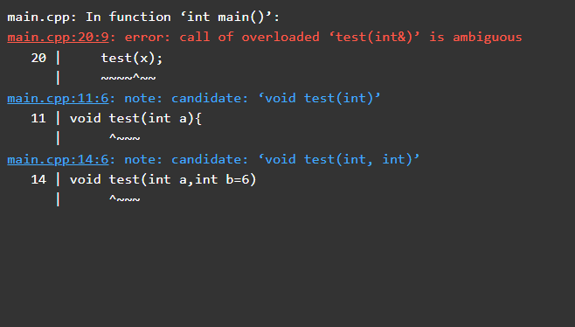

**Overload the following operators for the Matrix class:**

**+ (addition): Allows addition of two matrices.**

**\* (multiplication): Allows multiplication of two matrices.**

**Ensure that the operations adhere to matrix addition and multiplication rules (e.g., matrix dimensions compatibility).**

**Input and Output:**

**Implement a function to input matrices from the user or use predefined matrices for testing purposes.**

**Display the result of matrix addition and multiplication operations using overloaded operators.**

**Testing and Output:**

**Create a main() function to test your Matrix class and its operator overloading functionality.**

**Test with multiple matrices of different dimensions to demonstrate compile-time polymorphism through operator overloading.**

#include <iostream>

using namespace std;

class Matrix {

private:

int m[10][10];

int rows;

int cols;

public:

Matrix(int r, int c) : rows(r), cols(c) {

for (int i = 0; i < rows; ++i) {

for (int j = 0; j < cols; ++j) {

m[i][j] = 0;

}

}

}

void inputMatrix() {

cout << "Enter matrix elements row-wise:" << endl;

for (int i = 0; i < rows; ++i) {

for (int j = 0; j < cols; ++j) {

cin >> m[i][j];

}

}

}

void displayMatrix() {

cout << "Matrix:" << endl;

for (int i = 0; i < rows; ++i) {

for (int j = 0; j < cols; ++j) {

cout << m[i][j] << " ";

}

cout << endl;

}

}

Matrix operator+(Matrix& matrix) {

Matrix result(rows, cols);

for (int i = 0; i < rows; ++i) {

for (int j = 0; j < cols; ++j) {

result.m[i][j] = m[i][j] + matrix.m[i][j];

}

}

return result;

}

Matrix operator*(Matrix& matrix) {

Matrix result(rows, matrix.cols);

for (int i = 0; i < rows; ++i) {

for (int j = 0; j < matrix.cols; ++j) {

result.m[i][j] = 0;

for (int k = 0; k < cols; ++k) {

result.m[i][j] += m[i][k] * matrix.m[k][j];

}

}

}

return result;

}

};

int main() {

Matrix A(3, 3);

Matrix B(3, 3);

cout << "Enter elements for matrix A:" <<endl;

A.inputMatrix();

cout << "Enter elements for matrix B:" <<endl;

B.inputMatrix();

cout << "Matrix A:" <<endl;

A.displayMatrix();

cout << "Matrix B:" <<endl;

B.displayMatrix();

Matrix C = A + B;

cout << "Result of A + B:" <<endl;

C.displayMatrix();

Matrix D = A * B;

cout << "Result of A * B:" <<endl;

D.displayMatrix();

return 0;

}

**Output:**

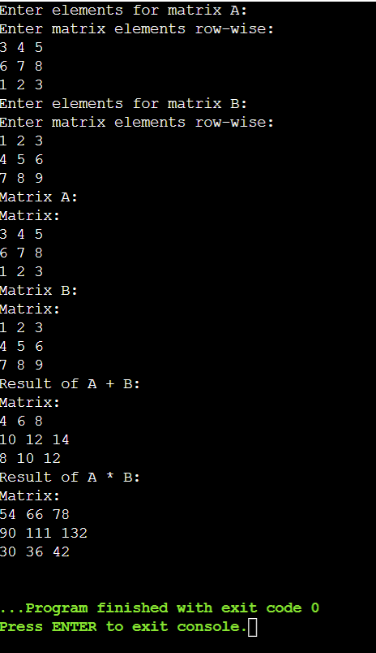

**Operator overloading:**

**Problem Statement: Distance Calculation Using Operator Overloading**

**You are required to implement a program that calculates distances using operator overloading in C++. The program should be able to perform the following operations on distances:**

**Addition of Distances:**

**Implement an addition operator (+) that adds two distances together.**

**The distance should be represented in feet and inches.**

**Subtraction of Distances:**

**Implement a subtraction operator (-) that subtracts one distance from another.**

**Ensure that the subtraction operation handles cases where the result may involve negative values or borrowing (like in subtraction of inches).**

**Comparison of Distances:**

**Implement comparison operators (==, !=, <, >, <=, >=) to compare distances based on their total length (combined feet and inches).**

**Use these operators to determine which distance is greater, less than, or equal to another.**

**Requirements:**

**Distance Class: Implement a Distance class with appropriate member variables (feet and inches).**

**Constructors: Implement constructors to initialize distances.**

**Member Functions: Implement member functions for display and any other necessary operations.**

**Operator Overloading: Overload the necessary operators (+, -, ==, !=, <, >, <=, >=) inside the Distance class to perform the specified operations.**

**Testing: Create a main() function to test the implemented Distance class and its operator overloading functionality. Test various scenarios including addition, subtraction, and comparison of distances.**

#include <iostream>

using namespace std;

class Distance {

private:

int feet;

float inches;

public:

Distance() : feet(0), inches(0.0) {}

Distance(int ft, float in) : feet(ft), inches(in) {}

void displayDistance() {

cout << "Feet: " << feet << " Inches: " << inches << endl;

}

Distance operator+(const Distance& d2) {

int totalFeet = feet + d2.feet;

float totalInches = inches + d2.inches;

if (totalInches >= 12.0) {

totalInches -= 12.0;

totalFeet++;

}

return Distance(totalFeet, totalInches);

}

Distance operator-(const Distance& d2) {

int totalFeet = feet - d2.feet;

float totalInches = inches - d2.inches;

if (totalInches < 0) {

totalInches += 12.0;

totalFeet--;

}

return Distance(totalFeet, totalInches);

}

bool operator== (Distance& d2) {

return (feet == d2.feet && inches == d2.inches); }

bool operator!=(Distance& d2) {

return !(*this == d2); }

bool operator<(Distance& d2) {

float thisTotal = feet + (inches / 12.0);

float d2Total = d2.feet + (d2.inches / 12.0);

return thisTotal < d2Total; }

bool operator>(Distance& d2) {

return !(*this < d2 || *this == d2); }

bool operator<=(Distance& d2) {

return (*this < d2 || *this == d2); }

bool operator>=(Distance& d2) {

return !(*this < d2); }

};

int main() {

Distance d1(10, 6.5);

Distance d2(5, 3.25);

Distance sum = d1 + d2;

cout << "Sum of distances: ";

sum.displayDistance();

Distance diff = d1 - d2;

cout << "Difference of distances: ";

diff.displayDistance();

if (d1 == d2)

cout << "Distances are equal" << endl;

else if (d1 != d2)

cout << "Distances are not equal" << endl;

if (d1 < d2)

cout << "Distance d1 is less than d2" << endl;

else if (d1 > d2)

cout << "Distance d1 is greater than d2" << endl;

return 0;

}

**Output:**

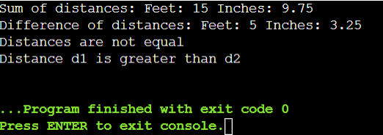

**Q.2 >>Problem Statement: Shape Area Calculator Using Method Overloading**

**You are required to implement a program that calculates the area of different shapes using compile-time polymorphism (method overloading) in C++. The program should support calculation of areas for the following shapes:**

**Rectangle**

**Circle**

**Triangle**

**Requirements:**

**Shape Class: Implement a Shape class as a base class with virtual functions to calculate and display the area of each shape.**

**Derived Classes: Implement derived classes Rectangle, Circle, and Triangle, inheriting from Shape, each with overridden functions to calculate and display their respective areas.**

**Method Overloading: Use method overloading in the Shape class to define multiple calculateArea functions, each specific to one shape.**

**Input and Output: Implement a main() function to test the implemented classes by creating instances of each shape, inputting dimensions, and displaying their calculated areas.**

#include <iostream>

#include <cmath>

using namespace std;

class Shape {

public:

virtual void calculateArea() {

cout << "Calculating area of generic shape" << endl;

}

virtual void displayArea() {

cout << "Area: " << area << endl;

}

protected:

double area;

};

class Rectangle : public Shape {

public:

Rectangle(double l, double b) : length(l), breadth(b) {}

void calculateArea() override {

area = length * breadth;

}

private:

double length;

double breadth;

};

class Circle : public Shape {

public:

Circle(double r) : radius(r) {}

void calculateArea() override {

area = M_PI * radius * radius;

}

private:

double radius;

};

class Triangle : public Shape {

public:

Triangle(double b, double h) : base(b), height(h) {}

void calculateArea() override {

area = 0.5 * base * height;

}

private:

double base;

double height;

};

int main() {

Rectangle rect(5.0, 3.0);

Circle circle(4.5);

Triangle triangle(4.0, 2.5);

rect.calculateArea();

circle.calculateArea();

triangle.calculateArea();

cout << "Rectangle Area: ";

rect.displayArea();

cout << "Circle Area: ";

circle.displayArea();

cout << "Triangle Area: ";

triangle.displayArea();

return 0;

}

**Output:**

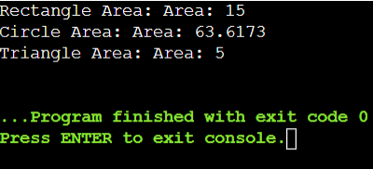

**Function Overriding:**

#include <iostream>

using namespace std;

class Animal {

public:

void eat(){

cout<<"Eating....";

}

};

class Dog:public Animal

{

public:

void eat()

{

cout<<"Eating bread.....";

}

};

int main(void){

Dog d = Dog();

d.eat();

return 0;

}

**Output:**

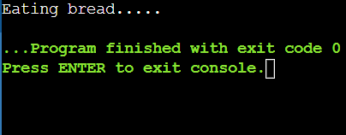

**Virtual Function:**

#include<iostream>

using namespace std;

class A{

int x=5;

public:

void display()

{

std::cout<<"Value of x is:"<<x<<std::endl;

}

};

class B:public A{

int y=10;

public:

void display()

{

std::cout<<"Value of y is:"<<y<<std::endl;

}

};

int main(){

A *a;

B b;

a = &b;

a->display();

return 0;

}

**Output:**

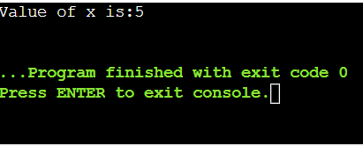

#include <iostream>

using namespace std;

class A {

public:

virtual void display()

{

cout<<"Base class is invoked"<<endl;

}

};

class B:public A{

public:

void display()

{

cout<<"Derived class is invoked"<<endl;

}

};

int main()

{

A *a;

B b;

a = &b;

a->display();

}

**Output:**

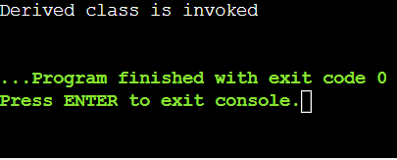

**Question 1: Shape Hierarchy**

**Create a base class Shape with a pure virtual function draw() that has no implementation. Derive classes Square, Circle, and Triangle from Shape. Each derived class should override draw() to provide its specific drawing behavior (e.g., printing "*" for square, "OOO" for circle, etc.). Write a function printShape(Shape shape) that takes a base class pointer and calls draw() on it. Demonstrate polymorphism by creating objects of the derived classes, storing them in a Shape* array, and calling printShape() on each element.**

#include <iostream>

using namespace std;

class Shape {

public:

virtual void draw() = 0;

virtual ~Shape() {}

};

class Square : public Shape {

public:

void draw() override {

cout << "Drawing a Square: *****" << endl;

}

};

class Circle : public Shape {

public:

void draw() override {

cout << "Drawing a Circle: OOOO" << endl;

}

};

class Triangle : public Shape {

public:

void draw() override {

cout << "Drawing a Triangle: #####" << endl;

}

};

void printShape(Shape* shape) {

shape->draw();

}

int main() {

Square square;

Circle circle;

Triangle triangle;

Shape* shapes[3];

shapes[0] = &square;

shapes[1] = &circle;

shapes[2] = &triangle;

for (int i = 0; i < 3; ++i) {

printShape(shapes[i]);

}

return 0;

}

**Output:**

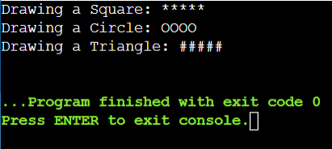

**Question 2: Animal Sounds**

**Design a base class Animal with a pure virtual function makeSound() that returns a string representing the animal's sound. Derive classes like Dog, Cat, and Bird from Animal, each overriding makeSound() with the appropriate sound ("Woof!", "Meow!", "Chirp!"). Create a function playAnimalSound(Animal* animal) that takes an Animal pointer and calls makeSound(). Populate an Animal* array with various animal objects and use playAnimalSound() to hear their sounds polymorphically.**

#include <iostream>

#include <string>

using namespace std;

class Animal {

public:

virtual string makeSound() = 0;

};

class Dog : public Animal {

public:

string makeSound() override {

return "Woof!";

}

};

class Cat : public Animal {

public:

string makeSound() override {

return "Meow!";

}

};

class Bird : public Animal {

public:

string makeSound() override {

return "Chirp!";

}

};

void playAnimalSound(Animal* animal) {

cout << animal->makeSound() << endl;

}

int main() {

Dog dog;

Cat cat;

Bird bird;

Animal* animals[] = { &dog, &cat, &bird };

for (int i = 0; i < 3; ++i) {

playAnimalSound(animals[i]);

}

return 0;

}

**Output:**

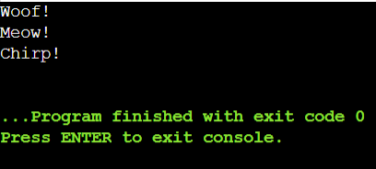

**Copy Constructor:**

#include<iostream>

using namespace std;

class Point{

public:

double x,y;

Point(){

x=0.0; y=0.0;

cout<<"default constructor"<<endl;

}

Point(double nx, double ny){

x = nx; y = ny;

cout<<"2-parameter constructor"<<endl;

}

};

int main(){

Point q(1.0,2.0);

Point r = q;

}

**Output:**

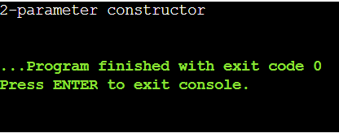

#include<iostream>

using namespace std;

class Point{

public:

double x,y;

Point(double nx,double ny){

x=nx; y=ny;

cout<<"2-parameter constructor"<<endl;

}

Point(Point &o){

x = o.x; y = o.y;

cout<<"custom copy constructor"<<endl;

}

};

int main(){

Point q(1.0,2.0);

Point r = q;

}

**Output:**

